Brandon Lee  
14010627X  
11/30/14  
Assignment 3

*Complete project is included. Full working source code can be found there.*

*Please note it may be required to only have one project open at a time to avoid errors due to project collisions*

**Problem 1**

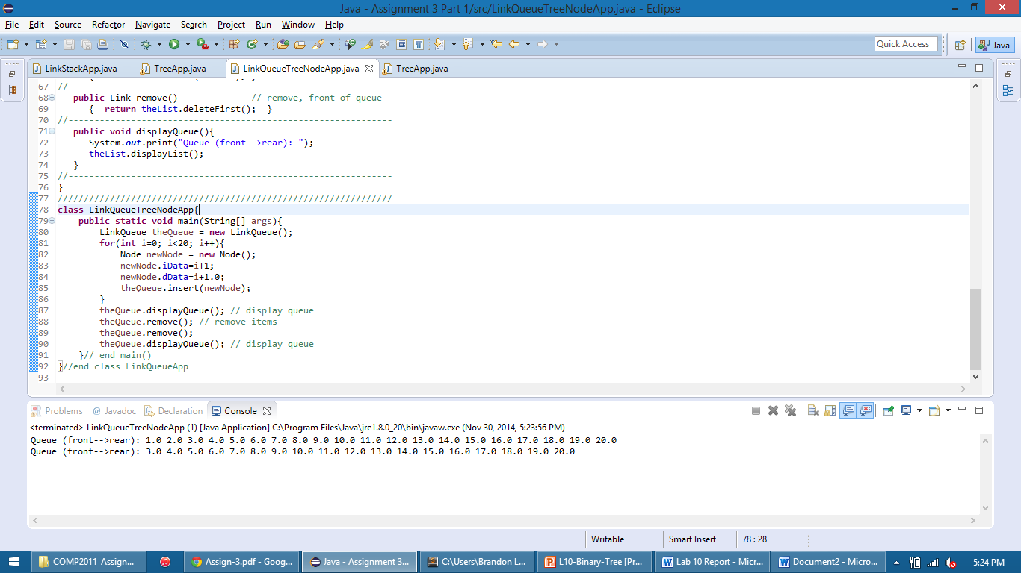

**Problem 2**

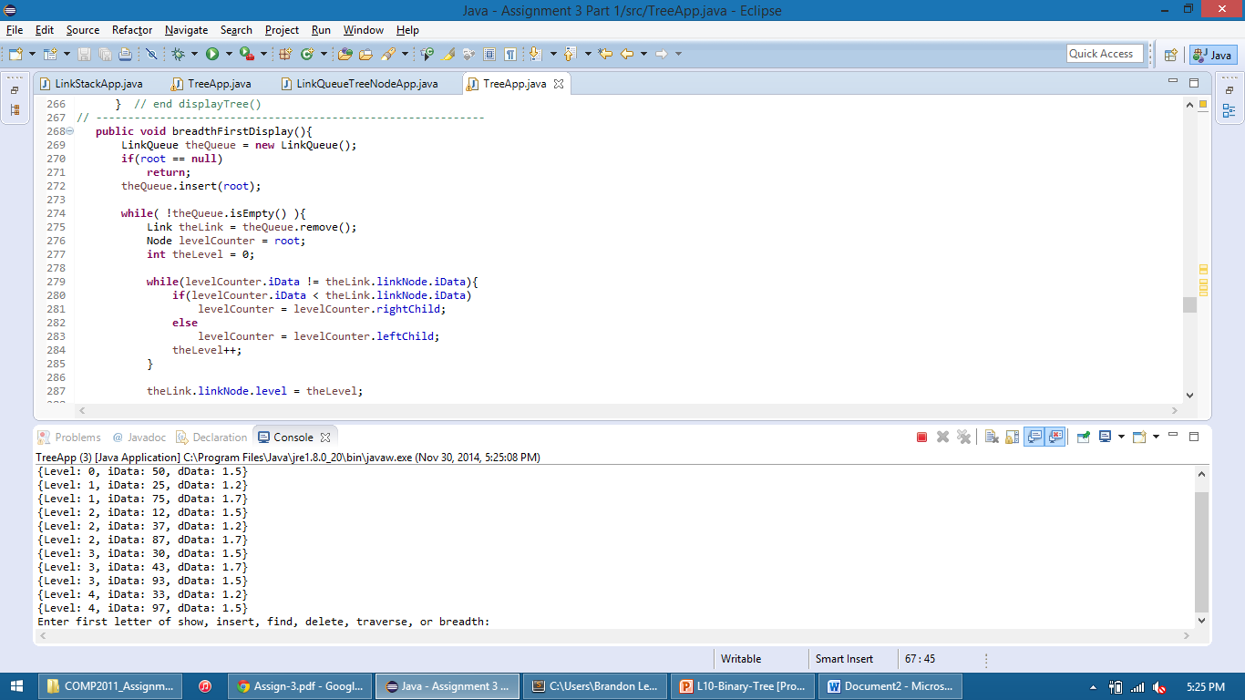

**Problem 3**

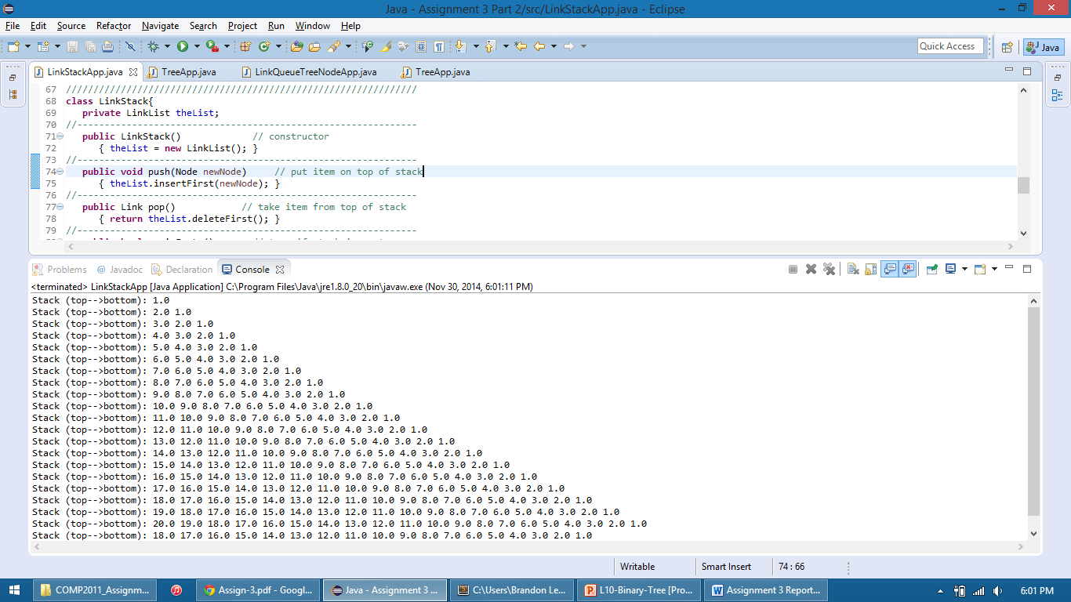

**Problem 4**

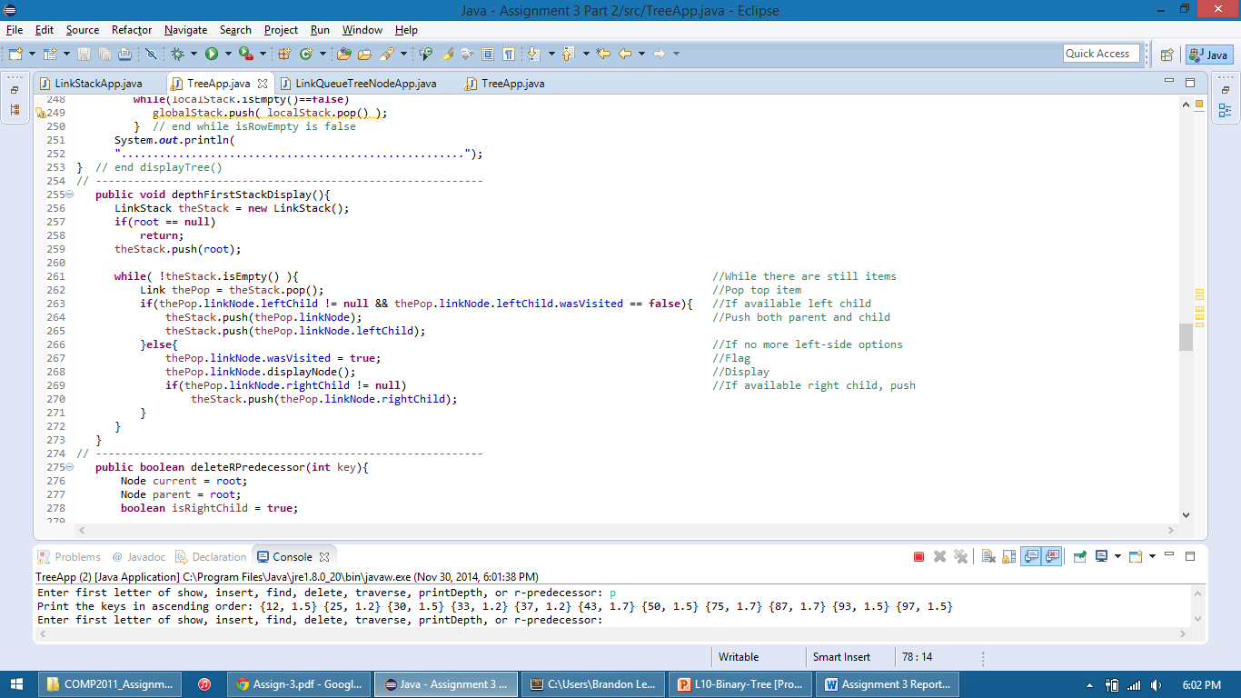

**Problem 5**

